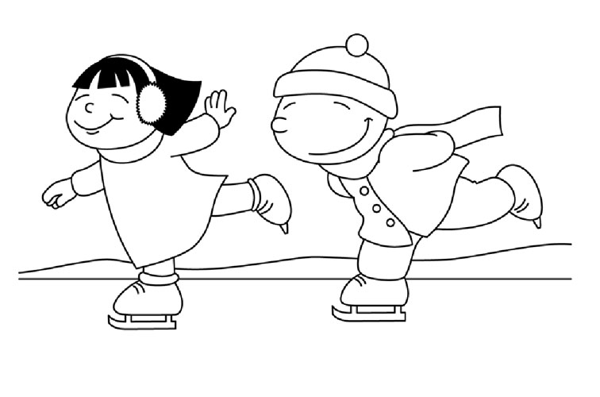
Learn to Skate Class Registration –
SouthRidge Mall - 1111 East Army Post Road, Des Moines, IA 50315
To enroll call 515-371-8666 or email: burtonpowley@mchsi.com
Website: http://www.theiceridge.com
Option 1: 4 week punch card (does not expire) COST $52.00 Class fee includes:
Best Value - Option 3: 8 week punch card (does not expire) (Save $15 off 4 week price)
COST $169.00 $89 Class Fee + $80 Jackson Mystique Figure Skate Purchase – Retail Value $130
$ave $50 off regular skate purchase price!!
Total Enrollment fee for this special deal is $169
Class and Skate Package Deal includes
- Skate ordered to your size
- 30 minute group class
- One year ISI (Ice Skating Institute) membership – includes secondary insurance
- One (1) Free Public Skate Pass per week– must check in at registration desk to use free pass.
*Please allow 1 extra week to order your skates, if choosing the skate and lesson option 3.
- 30 minute group class
- One year ISI (Ice Skating Institute) membership – includes secondary insurance
- One (1) Free Public Skate Pass per week – must check in at registration desk to use free pass.
- Skate Rental included
Option 2: 8 week punch card (does not expire) COST $89.00 (Save $15) Class fee includes:
- 30 minute group class
- One year ISI (Ice Skating Institute) membership – includes secondary insurance
- One (1) Free Public Skate Pass per week – must check in at the registration desk to use free pass.
- Skate Rental included
Students may make- up missed classes, if classes are available.
You may take multiple classes per week.
Check in at counter and present punch ticket to staff, before class starts.
Lost punch tickets will NOT be replaced.

Registration Options: Walk-in and Register, Call in Registration, Mail in Registration, Email Online Registration
Pick up your punch tickets at registration desk.

Cancellation Policy - We cannot be responsible for cancelled classes due to bad weather or snow or
unforeseen circumstances. If the Mall closes, we will be closed, too.
Students are free to make-up classes anytime classes are held.
Every attempt will be made to accommodate all students for make-ups. Walk-ins will be accepted if
space allows. $15 per class walk-in price. You can join anytime! Classes are ongoing throughout the year.

- Learn to Skate Class Registration Form
Skaters Name: Birth date (MM/DAY/YYYY)______________________Age:______Skate Size________
Parents Name:
Address: Best phone to contact you? Home: Cell:
Email:
Class Levels - Pick One or more (10% discount for multiple class enrollments, includes family discounts for 2 or more skaters) All Classes will be offered on all days. 30 minute class periods. Sunday, Monday and Thursday 6-8pm. Saturday 9-11am. Please be prepared to take lessons anytime in the 2 hour block. You will be contacted with your exact lesson time once enrollments are received. Generally we will start with the Tots and progress to the adults and figure skaters. If you do not know your skating level, we will evaluate you during your first class and move you to the appropriate level.
Tots 1-4 (ages 4-6) PreAlpha- Delta – Basic Skills (ages 6-12) Teen (ages 12-18) Freestyle (Figure Skating) Adults (18 & over please)
Anyone can enroll in the following classes regardless of age. Theatre/Choreography class Off-ice fitness & stretch class Other____________
Option 1 - $52 - 4 weeks Option 2 - $89 - 8 weeks Option 3 - $169 – 8 weeks plus new skates - Skate Size ______ ISI # if member: _________________
Total Due $____________________________________
Register early as many of our classes will fill quickly and have limited enrollment numbers. Classes with insufficient registrations may be combined with similar levels in order to provide an opportunity for all skaters. If choosing the Option #3 Skate package, please allow 1 extra week for skate delivery and fitting. You will be contacted if any class needs to be cancelled and offered a refund or credit for future classes. Learn to Skate Punch tickets do NOT expire. Lost Punch tickets will NOT be replaced.
Assumption of Risk of and Release: I am aware that ice skating involves inherent risks, dangers, and hazards which can result in personal injury or death. I hereby freely assume and accept any and all known and unknown risks of injury while skating at this facility, and release owner, its management company, their affiliates, subsidiaries, successors and assigns for any liability whatsoever for bodily injury or property damage resulting from any negligent acts and omissions in the design, operation, supervision and maintenance of the facility.
Signature: X______________________________________________________________
Payment type: Cash_____ Check # ___________Visa/MC ___________________________________Exp. Date (MM/YY)__________3 digit code#_________
Cardholder name as it appears on card: ________________________________________________

